**Project Title**

**To determine which is the best location in city to spent holiday**

**BY**

**Abhishek Chandra**

**For**

**IBM DATA SCIENCE CAPSTONE PROJECT**

**Introduction**

**Project Description**

In this project I am going to determine the neighborhood of a city which is suitable to spent holiday. This decision was taken on the basis of current season and popularity among previous visits of peoples. This can be useful for in many ways like taking right place for holiday in a city. This can be more useful to travelers or the people who love visiting different countries to gain knowledge about their cultures and historic and ethics values. This project show results of different historic places, parks and nature rich places.

Only things that user has to do is to select the cities that they are planning to visits and the program show the results by calculating various aspects and show you the best places and city that user can visit to spent holidays.

It uses recommendation system to recommend the perfect venues for the users.

**Data Description**

For gathering the data I used foursquare api to obtain:

1. venues near places
2. latitude and longitude of the venues
3. categories of the venues

sample of data obtain from foursquare api (i used the location 'washington' so i get all the venues present around washington)

sample of data :

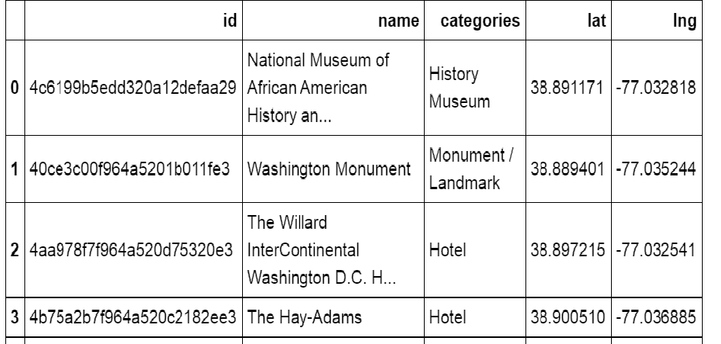

For user data i give static input in json format which is later be processed using foursquare api to obtain the same features like latitude and longitude, categories of venues.

**sample user input** : it contains data of venues that user already visited

|  |  |  |
| --- | --- | --- |
| index | Venue_name | rating |
| 1 | Eiffel Tower | 6.4 |
| 2 | Taj Mahal | 6.4 |
| 3 | Dal Lake | 8.9 |

This data will be further processed in foursquare api and give detailed information about the venue_name

**Methodology**

Different methods that is used in this projects are as:

1. **Foursquare api** : This api is used to get venues and its detailed information. Sample data is shown in A2 section of this article
2. **K-means clustering** : This method is used to cluster the recommended venues on the basis of their categories.
3. **Recommendation System** : Recommendation system method is used to determine the types of places that user liked to visits by determining the relationship between user_input data and global data that is obtained from foursquare api.1
4. **Folium Library :** This library is used to plot the recommended places/venues in a map by separating it through clusters.

**Results**

This project is divided into three parts and the results of all this part is then used to plot folium map of recommended venues.

1. **Recommended places :** result of recommended places are obtained by calculating the weights. sample output of this section is:

id

4a500fe1f964a520f2af1fe3 0.455516

51a2445e5019c80b56934c75 0.455516

40ce3c00f964a5201b011fe3 0.455516

4a10649df964a520b7761fe3 0.455516

4a491e86f964a520ffaa1fe3 0.455516

4a518853f964a5201bb11fe3 0.455516

2. **Onehot encoding :** This leads to perform kmeans clustering in third part of the code. Sample output for this part is :

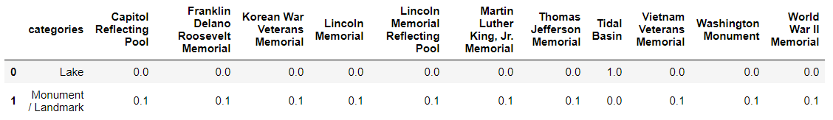

3**. K-means clustering:** This leads to cluster the data on the basis of categories since there are only two categories for this data so it will cluster the data in 2 clusters.

Finally I plot a folium map for the recommended places which gives the final results of the project.

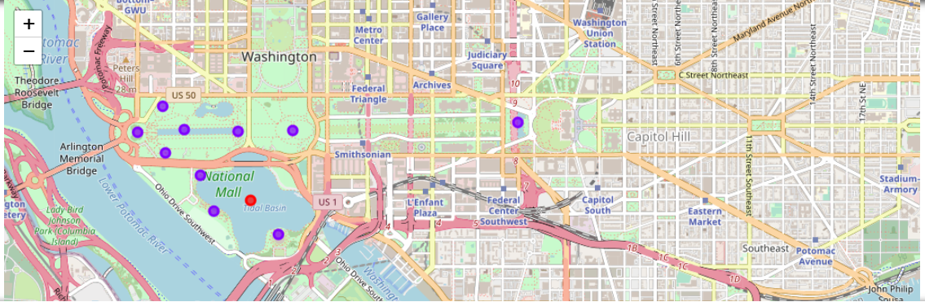

Here the point in red represents the category 'Lake' and point in blue represents the category ' Landmark/Monument'

**D. Conclusion:**

As a result, people are traveling to different cities to visits different historic venues or tourist venues as per their preference categories.

**E. References:**

1. Foursqaure API
2. Google map